CREATING A DJANGO PROJECT FROM SCRATCH

1. Activate your virtual enviroment using the call command
   1. Call {{enviroment name}}\Scripts\activate
   2. You can use the command “pip freeze” (no quotations) to verify that Django is installed and up to date
2. CD to the folder that contains your main project, i.e., your desktop, python projects, etc
3. Run the following command: django-admin startproject {{project_name}}
4. Navigate to the folder you just created and run “python manage.py runserver”
5. In your web browser, go to Localhost:8000
   1. This will verify that all is well if you see the django screen
6. Stop the server
7. Run the following to make your app: django-admin startapp {{app_name}}
   1. The app name MUST be different than your project name
8. Run the command “code .” ##This might only work in windows
9. Now that your code console is open, find the settings.py file
   1. Scroll down to “INSTALLED_APPS, and add the following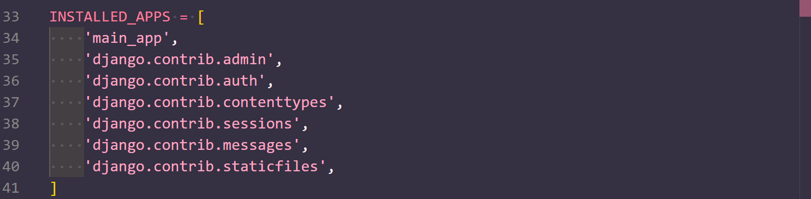
   2. All you add is the new line 34. Don’t delete anything, just make sure that line is added
10. Now we need to create our routes. Go to the “URLS.PY” file and make it match the following:

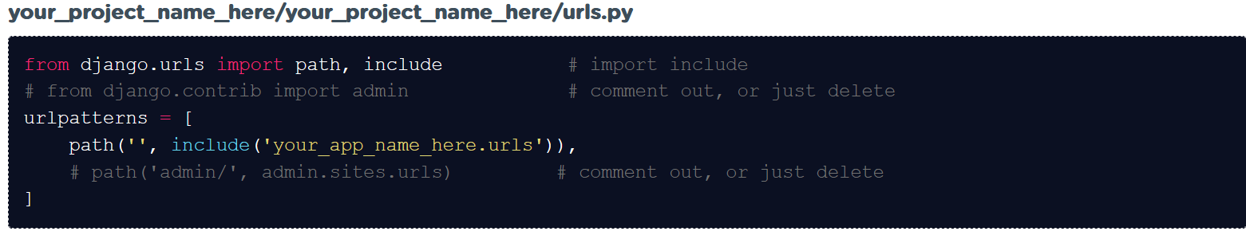

1. Now let’s go to our APP folder. Create a “URLS.PY” file in the app folder and make it look like this:

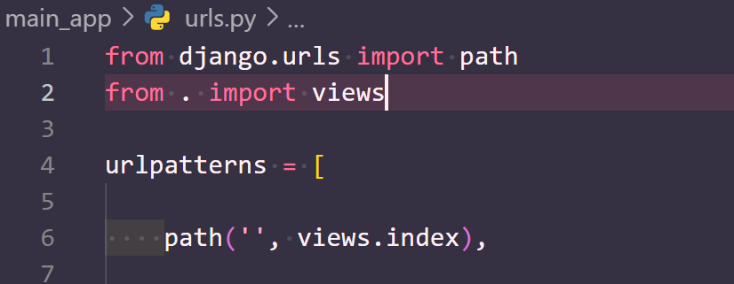

1. Now, lets edit our “VIEWS.PY” in our app:

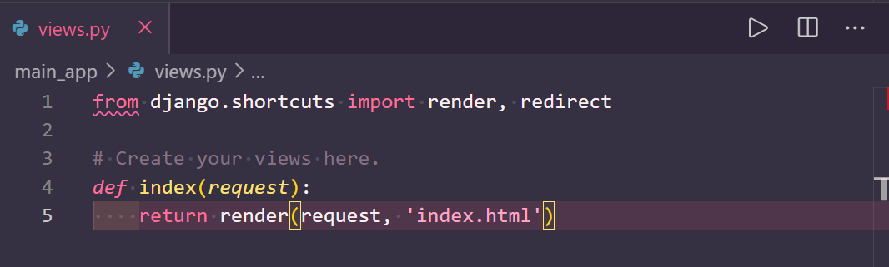

1. In your app folder, make a new folder called **templates. It must be lowercase and plural.** 
   1. Inside here make an html file called index.html and configure it how you like
   2. Don’t forget that you can use ! as a shortcut to set it up
2. For our last setup step, let’s address the migrations. First, in your terminal run “python manage.py makemigrations”, then run “python manage.py migrate”
3. Finally, lets restart our server with “python manage.py runserver”, and refresh our web browser at localhost:8000
   1. If all went well, you should see your HTML page. If not, check your spacing, indents, and spelling